Problem No:
Problem Statement:
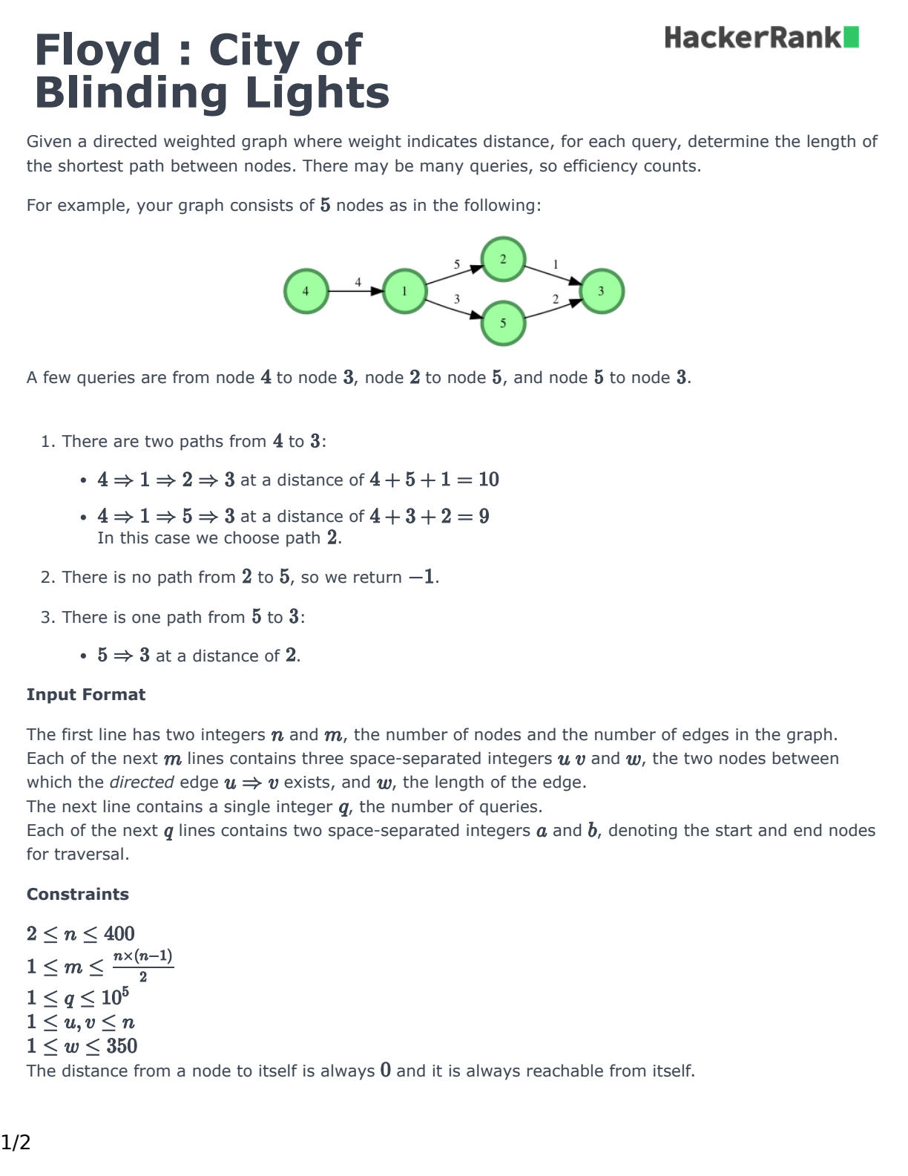

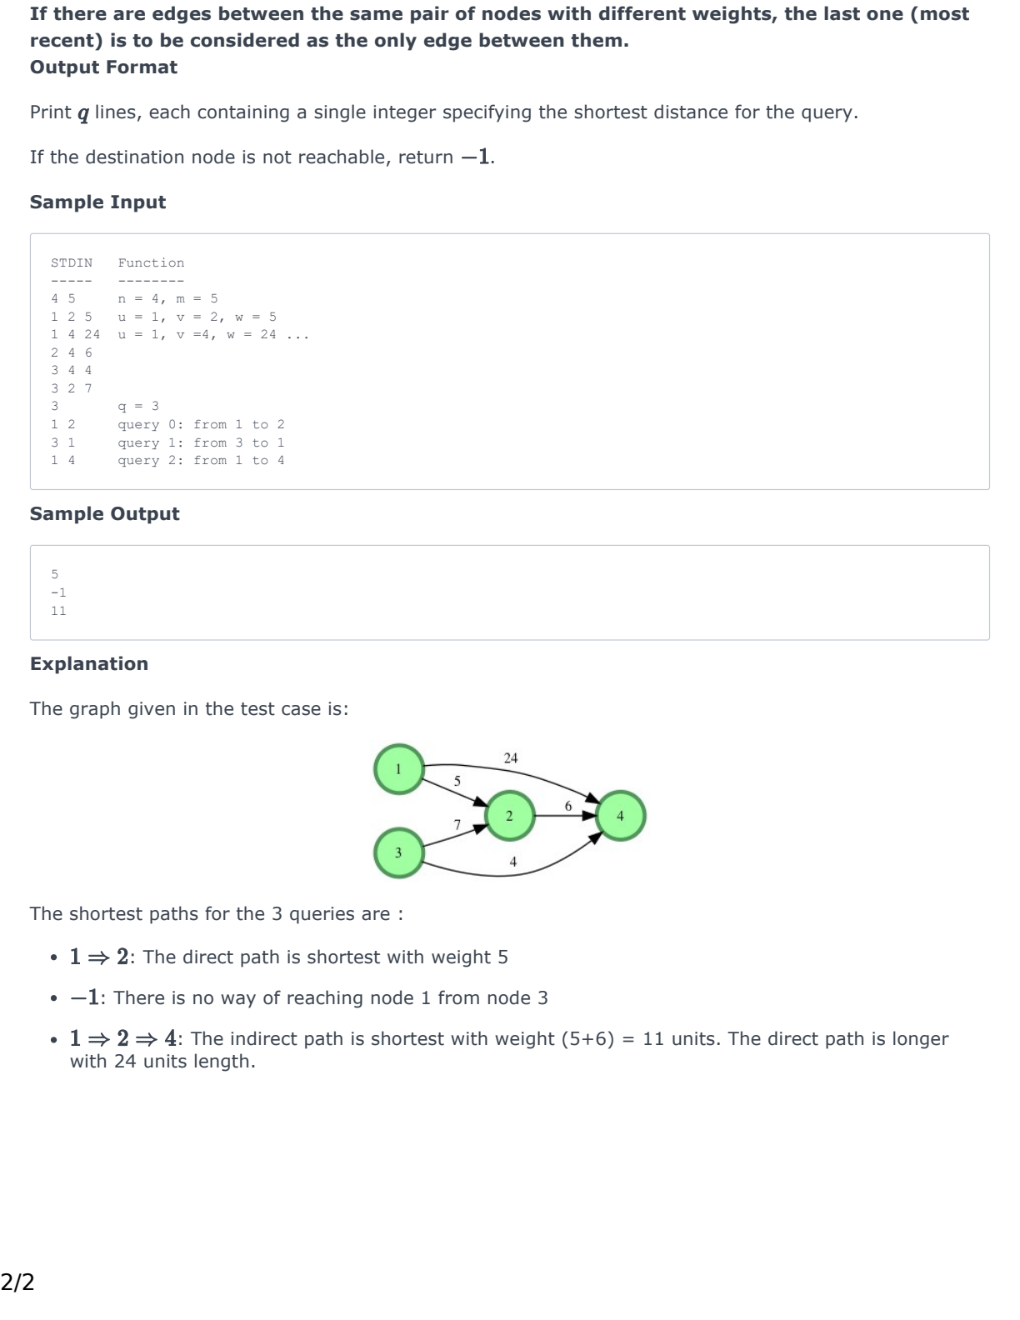

Codes:
#include <bits/stdc++.h>
using namespace std;

static const int INF = 99999;
int dis[401][401];

int main()
{

int n, m;
cin >> n >> m;

for (int i = 1; i <= n; i++)
{
for (int j = 1; j <= n; j++)
{
if (i != j)
dis[i][j] = INF;
else
dis[i][j] = 0;
}
}

for (int i = 0; i < m; i++)
{
int u, v, w;
cin >> u >> v >> w;
dis[u][v] = w;
}

for (int k = 1; k <= n; k++)
{
for (int i = 1; i <= n; i++)
{
for (int j = 1; j <= n; j++)
{
if (dis[i][k] + dis[k][j] < dis[i][j])
{
dis[i][j] = dis[i][k] + dis[k][j];
}
}
}
}

int q;
cin >> q;
while (q--)
{
int a, b;
cin >> a >> b;
if (dis[a][b] == INF)
cout << -1 << "\n";
else
cout << dis[a][b] << "\n";
}

return 0;
}

Output:

